13.90: The moment of inertia about the pivot is 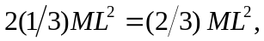 and the center of gravity when balanced is a distance 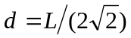below the pivot (see Problem 8.95). From Eq. (13.39), the frequency is

